**Gateway Patterns and Design Principles**

**Gateway Patterns and Design Principles**

**Introduction**

In microservices-based and cloud-native architectures, **API Gateways** serve as the bridge between external clients and internal service logic. To optimize the effectiveness of these gateways, architects use established **design patterns and principles** that improve performance, scalability, security, and maintainability.

**Common Gateway Design Patterns**

1. **Gateway Routing Pattern**

The gateway acts as a smart router that directs client requests to the correct microservice based on the URL path, headers, or method.

*Example:*  
/api/users → User Service  
/api/products → Product Catalog Service

1. **Backend for Frontend (BFF) Pattern**

This pattern creates a custom API gateway for each type of client (e.g., mobile, web, IoT) to tailor data aggregation and reduce over-fetching or under-fetching.

*Use Case:*  
A mobile client may need lighter responses than a web dashboard, so the BFF handles this logic.

1. **Aggregator Pattern**  
   Combines responses from multiple microservices into one payload, minimizing the number of client-side requests.

*Example:*  
A “User Profile” page may require data from user, order history, and recommendation services. The gateway aggregates and sends a single response.

1. **Authentication Gateway Pattern**  
   Centralizes user authentication and token validation using OAuth2, JWT, or API keys.
2. **Rate Limiting and Throttling Pattern**  
   Protects backend services from abuse and ensures fair usage by applying traffic control at the gateway layer.
3. **Transformation Pattern**  
   The gateway modifies request/response headers or payloads (e.g., XML → JSON) for client-specific requirements.

**Design Principles for Effective API Gateways**

| **Principle** | **Explanation** |
| --- | --- |
| **Loose Coupling** | Clients should not be directly tied to service endpoints. |
| **Abstraction** | Hide the internal architecture and service evolution from clients. |
| **Security First** | Apply authentication, authorization, and traffic management at the edge. |
| **Scalability** | Design gateways to support autoscaling and load balancing. |
| **Monitoring and Logging** | Enable observability by logging all API transactions. |
| **Version Management** | Support routing to multiple API versions for backward compatibility. |
| **Performance Optimization** | Use caching, compression, and asynchronous communication when possible. |

**Use Case Example: Ride-Sharing App**

In a ride-sharing app like Uber:

* The API Gateway routes /driver, /rider, /payment, and /map requests to their respective services.
* It handles user authentication centrally.
* For mobile clients, it uses the BFF pattern to reduce bandwidth.
* Aggregates ride status, driver location, and ETA into a single response.

**Where Apigee Fits into the Architecture**

**Introduction to Apigee**

**Apigee** is Google Cloud’s full-featured API Management platform that enables enterprises to design, secure, publish, monitor, and analyze APIs. It acts as an advanced API Gateway and Management layer for both monolithic and microservices-based applications.

**Apigee in a Typical Microservices Architecture**

**Architecture Placement**

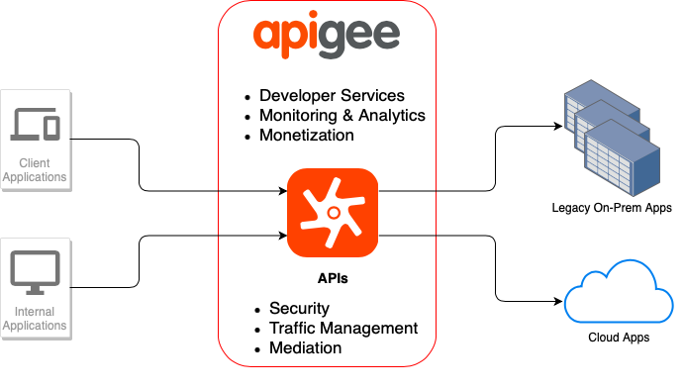

Apigee sits between the **client layer** and the **microservices layer**. It abstracts the internal services and exposes a unified, secure API layer.

**Key Capabilities of Apigee**

| **Feature** | **Role in Architecture** |
| --- | --- |
| **Traffic Management** | Load balancing, quota enforcement, rate limiting |
| **Security** | OAuth2, JWT, API key validation, threat protection (e.g., spike arrest) |
| **Analytics and Monitoring** | Built-in dashboards for traffic, latency, and error rates |
| **Developer Portal** | Enables external partners or teams to discover and use APIs |
| **Policy Engine** | Reusable rules for transformation, mediation, and flow control |
| **CI/CD Integration** | API lifecycle management with GitOps and DevOps workflows |
| **Monetization Support** | Allows businesses to expose APIs for revenue generation |

**Use Case Example: Banking API Platform**

A large bank wants to expose its services (like account info, transaction history, credit card APIs) to:

* Mobile App
* Third-party fintech partners (via Open Banking)
* Internal teams

**Solution with Apigee:**

* Apigee enforces OAuth2 and scopes.
* It tracks API usage by partners.
* The gateway transforms and validates all requests before hitting backend services.
* Provides analytics on API usage for internal KPIs and regulatory reporting.

**Benefits of Using Apigee in Microservices**

* **Security at Scale**: Centralized policy enforcement without changing backend code.
* **Hybrid Deployments**: Supports on-premises, cloud, and hybrid environments.
* **API Versioning & Deprecation**: Easily manage multiple API versions.
* **Traffic Insights**: Detailed analytics for API traffic trends and client behavior.
* **Lifecycle Management**: Design → Secure → Publish → Monitor → Monetize in one platform.

**Comparing Apigee with Basic API Gateways**

| **Feature** | **Apigee** | **Basic API Gateway (e.g., NGINX)** |
| --- | --- | --- |
| **API Analytics** | Advanced, built-in | Minimal or external integration |
| **Developer Portal** | Included | Not always available |
| **Policy Management** | Visual and extensible policies | Manual scripting |
| **Monetization** | Supported | Not supported |
| **Security** | OAuth2, Spike Arrest, Threat Protect | Basic Authentication |

**Conclusion**

API Gateways are vital for managing the communication between clients and microservices. Patterns like BFF, request aggregation, and rate limiting help streamline application delivery. Apigee, with its enterprise-grade features, fits seamlessly into modern microservices architecture by providing a unified platform for **API management, security, scaling, and analytics**. It enhances agility, secures sensitive data, and improves developer productivity—making it a go-to choice for enterprise-grade API ecosystems.